[](https://ejpsoil.eu/)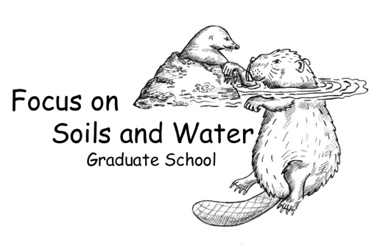

**Soil systems: Analytical methods for integrating the chemical, biophysical interface in soils**

**Literature meeting III**

**Course task: Assessment whether a soil system view is critical to own scientific work**

***15th of June, 9:00 – 12:00***

***zoom meeting:*** <https://slu-se.zoom.us/j/61771604255?from=addon>

***passcode:*** 288509

**Importance of soil system sciences for ecosystem services – various scales**

* Screen through the papers proposed in the literature list and summarize one of them (your own choice).
* Do you have any specific questions regarding the papers?

*Literature list*

Janzen, H.H, Janzen, D.W., Gregorich, E.G. 2021. The „soil health“ metaphor: Illuminating or illusory? Soil Biology and Biochemistry 159, 108167.

Keiluweit, M. et al. 2015. Mineral protection of soil carbon counteracted by root exudates. Nature Climate Change 5, 588–595.

Lehmann, J., Bossio, D.A., Kögel-Knabner, I., Rillig, M.C. 2020. The concept and future prospect of soil health. Nature Reviews Earth and Environment 1(10), 544-553.

Weng, Z. et al. 2021. Probing the nature of soil organic matter. Critical Reviews in Environmental Science and Technology.